jhoffmann@nexstar.tv

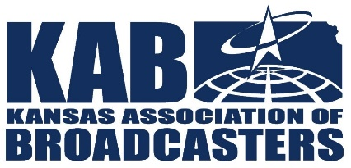
KANSAS ASSOCIATION OF BROADCASTERS
534 S. Kansas Ave., Suite 1105 ∙ Topeka, KS 66603 ∙ (785) 235-1307 ∙ info@kab.net
PEP TV SUMMARY
Effective June 1, 2024

*Changes in Red* Please stop running any PEP ADs that are not listed below.

:15 SPOTS
KS Army National Guard (ARNG) ISCI Code Kill Date
- ARNG – Kansas Service_15 ARNG4444 Mar. 31, 2025

:30 SPOTS
KS Bankers Association (KBA) ISCI Code Kill Date
- KBA Codeword :30 KSBA2002 Jun. 30, 2024

KS Army National Guard (ARNG) ISCI Code Kill Date
- ARNG – Kansas Service_30 ARNG1124 Mar. 31, 2025

KS Dept. of Education (KDOE) ISCI Code Kill Date
- Summer Meals: 30 KDOE2024 July 31, 2024

TV Spot Downloads can be found here:
- All Spots can be found on: Radio NCSA MP3s - Kansas Association of Broadcasters (kab.net)

Note: Be sure to use the ISCI code or Campaign full title on all affidavits.
To the extent possible, split the value of these orders over ALL day parts as follows:
1/3 of $ Value: 5 a.m. - 12 noon 1/3 of $ Value: 12 noon - 6 p.m. 1/3 of $ Value: 6 p.m. - 12 midnight

